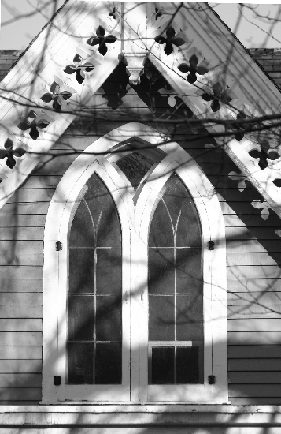
Introducing Christ Presbyterian Church’s
Media Center
Now available to you in the foyer area & our Website….

There are many items for sale in both audio and MP3 format in the Media Center.

 Recent Sunday morning sermons are now in MP3 format. Visit the direct link at our web site at http://www.christpresnewhaven.org/sts/sermons/downloadsindex.html
These files are fairly large and it would be helpful to have a high speed internet line (cable or DSL) to download. They download directly to your computer and bypass the email process.
*** The last 6 weeks of sermons are available, including the sermon by Rob Cox – please note there is a 1 minute of silence at the beginning of that sermon.

 AUDIO Formatted CDs
The Ten Commandments (12 CDs)
Intro to Reformed History (5 CDs) Darren Provost
Intro to CPC & Reformed World View (6 CDs) Rev. Preston Graham
Leadership Training Course (7 CDs) Rev. Preston Graham
Vocational Calling (1 CD) Adult Sunday School Class
True Spirituality (2 CDs) Rev. Preston Graham on John 15
Marriage Sermon (1 CD) Rev. Preston Graham
 MP3 Formatted CDs
Series on Exodus (21 Sermons) Rev. Preston Graham
Theology Course 2003/2004 (2 CDs) 21 ~2+ hr Classes
Theology Class 2001 and 2000 Years of Sacred Music
by Dan Kellogg (2 CDs) (18 Classes in Theology & 5 classes by Dan Kellogg)
 You are also welcome to order individual sermons on CD or tapes by request using the provided forms located in the Media Center.
Introducing Christ Presbyterian Church’s
Media Center
Now available to you in the foyer area & our Website….

There are many items for sale in both audio and MP3 format in the Media Center.

 Recent Sunday morning sermons are now in MP3 format. Visit the direct link at our web site at http://www.christpresnewhaven.org/sts/sermons/downloadsindex.html
These files are fairly large and it would be helpful to have a high speed internet line (cable or DSL) to download. They download directly to your computer and bypass the email process.
*** The last 6 weeks of sermons are available, including the sermon by Rob Cox – please note there is a 1 minute of silence at the beginning of that sermon.

 AUDIO Formatted CDs
The Ten Commandments (12 CDs)
Intro to Reformed History (5 CDs) Darren Provost
Intro to CPC & Reformed World View (6 CDs) Rev. Preston Graham
Leadership Training Course (7 CDs) Rev. Preston Graham
Vocational Calling (1 CD) Adult Sunday School Class
True Spirituality (2 CDs) Rev. Preston Graham on John 15
Marriage Sermon (1 CD) Rev. Preston Graham
 MP3 Formatted CDs
Series on Exodus (21 Sermons) Rev. Preston Graham
Theology Course 2003/2004 (2 CDs) 21 ~2+ hr Classes
Theology Class 2001 and 2000 Years of Sacred Music
by Dan Kellogg (2 CDs) (18 Classes in Theology & 5 classes by Dan Kellogg)
 You are also welcome to order individual sermons on CD or tapes by request using the provided forms located in the Media Center.

